Code Level Documentation: COSEC NL2SQL Agent
This document provides a detailed technical understanding of the COSEC NL2SQL Agent project, following the C4 Model (Code Level).
Project Overview
- Name: COSEC NL2SQL Agent
- Description: A robust middleware that converts natural language queries into secure MS SQL queries for the Matrix COSEC system, executes them, and returns human-friendly summaries.
- Location: c:\Users\ANT PC\Desktop\cosec lib\nl2sql_agent
- Primary Languages: JavaScript (Node.js), HTML (Vanilla JS), Python (Testing/Auditing)

1. Main Components & Code Structure
[Core Server] nl2sql_agent.js
The heart of the application. It manages the Express API, AI provider failover (Groq & Gemini), database connection pooling, and the orchestration of the NL2SQL pipeline.
Key Functions:
- queryAI(prompt: string): Promise<string>
  - Purpose: Primary interface for LLM calls. Implements a round-robin failover strategy using a pool of Groq API keys and falls back to Gemini if all Groq keys fail or are rate-limited.
  - Logic: 1. Try Gemini (Primary) -> 2. Try Groq Pool (Fallback) with round-robin index.
- app.post('/api/nl2sql') (Express Route)
  - Purpose: Orchestrates the entire request flow.
  - Pipeline:
    - Receive prompt.
    - Construct system prompt with current IST date and schema context (nl2sql-skill.md).
    - Call queryAI for SQL generation.
    - Clean/Correct SQL (Middleware fail-safe for common LLM hallucinations).
    - Validate SQL using sql_validator.js.
    - Execute SQL via mssql pool.
    - Call queryAI again for human-friendly summary generation based on results.
    - Log success/error to query_analysis.log.

[Security Layer] sql_validator.js
A defensive middleware that ensures no destructive or unauthorized SQL reaches the database.
Class: SQLValidator
- Logic:
  - Whitelist: Ensures queries start with SELECT, WITH, or ;WITH.
  - Blacklist: Rejects any query containing destructive keywords (DROP, DELETE, UPDATE, EXEC, etc.) using regex with word boundaries.
  - Single Statement: Prevents SQL injection via multiple statements by splitting on ;.

[Knowledge Base] nl2sql-skill.md
A Markdown-based system context file that acts as the "brain" for the AI. It contains:
- Full Schema Definitions: Views like Mx_VEW_DailyAttendance, Mx_VEW_VistorReport, etc.
- Business Logic Rules: IST time handling, canteen punch logic, visitor status mapping.
- Constraints: How to handle missing data or DOT-formatted UserIDs.

[Frontend UI] react_frontend.html
A single-file dashboard built with Tailwind CSS and Vanilla JS (no complex build step required).
- Features: Real-time query input, SQL preview, result table with dynamic columns, and AI-generated text summary.

2. Data Flow Diagram
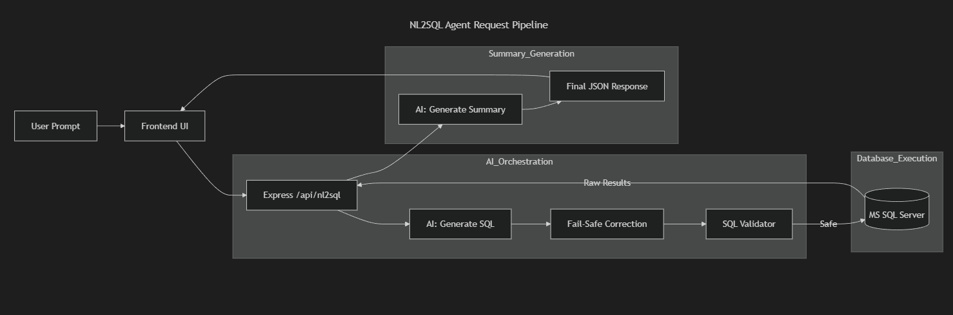

3. Dependencies
External Libraries (Node.js)
- express: Web framework.
- mssql: MS SQL Server driver with connection pooling.
- dotenv: Environment variable management (.env).
- cors: Cross-origin resource sharing support.
Python Utility Scripts
Used for offline auditing and testing:
- pyodbc: Direct SQL connectivity for schema extraction.
- requests: Testing the API endpoints.

4. Key Logic: Intelligent Fail-Safe
The nl2sql_agent.js includes a hardcoded correction map to fix common LLM mistakes without retraining the model:
const corrections = {
'Item_name': 'ItemName',
'DeptName': 'DptName',
'Mx_VEW_DailyAttendanceComplete': 'Mx_VEW_DailyAttendance',
// ... more mappings
};
This ensures high reliability even when the LLM hallucinates slightly different column names.

